ГОСУДАРСТВЕННОЕ БЮДЖЕТНОЕ ПРОФЕССИОНАЛЬНОЕ ОБРАЗОВАТЕЛЬНОЕ УЧРЕЖДЕНИЕ

«НИЖЕГОРОДСКИЙ ГУБЕРНСКИЙ КОЛЛЕДЖ»

ОТЧЕТ ПО УЧЕБНОЙ ПРАКТИКЕ

ПМ.06 Разработка и дизайн web-приложений

09.02.03 ПРОГРАММИРОВАНИЕ В КОМПЬЮТЕРНЫХ СИСТЕМАХ

г. Н. Новгород

2017 г.

Оглавление

# 1 ОБЩИЙ САЙТ

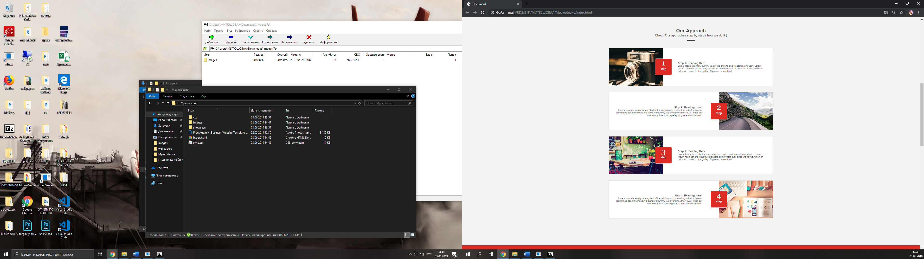

## HTML

<div class="showcase">

<div class="wrap">

<div class="zag">

<p3 style="color: #424242;"><b>Our Approch</b></p3>

<p2 style="color: #424242;">Check Our approches step by step ( how we do it )</p2>

<img src="images/Shape 10.png">

</div>

<div class="showcase-items">

<div class="item">

<div class="pcch">

<img class="link" src="images/showcase/1step.png">

</div>

<div class="stp">

<p3

style="font-family: Georgia, sans-serif; font-size: 50px; color: white">

1</p3>

<p2 style="font-family: Georgia, sans-serif; color: white">step</p2>

</div>

<div class="initem">

<h3>Step 1: Heading Here</h3>

<p>Lorem Ipsum is simply dummy text of the printing and typesetting

industry. Lorem Ipsum has

been the industry's standard dummy text ever since the 1500s,

when an unknown printer took a

galley of type and scrambled.</p>

</div>

</div>

<div class="item1">

<div class="stp1">

<p3

style="font-family: Georgia, sans-serif; font-size: 50px; color: white">

2</p3>

<p2 style="font-family: Georgia, sans-serif; color: white">step</p2>

</div>

<div class="initem1">

<h3>Step 2: Heading Here</h3>

<p>Lorem Ipsum is simply dummy text of the printing and typesetting

industry. Lorem Ipsum has

been the industry's standard dummy text ever since the 1500s,

when an unknown printer took a

galley of type and scrambled.</p>

</div>

<div class="pcch1">

<img class="link" src="images/showcase/2step.png">

</div>

</div>

<div class="item">

<div class="stp">

<p3

style="font-family: Georgia, sans-serif; font-size: 50px; color: white">

3</p3>

<p2 style="font-family: Georgia, sans-serif; color: white">step</p2>

</div>

<div class="pcch">

<img class="link" src="images/showcase/3step.png">

</div>

<div class="initem">

<h3>Step 3: Heading Here</h3>

<p>Lorem Ipsum is simply dummy text of the printing and typesetting

industry. Lorem Ipsum has

been the industry's standard dummy text ever since the 1500s,

when an unknown printer took a

galley of type and scrambled.</p>

</div>

</div>

<div class="item1">

<div class="stp1">

<p3

style="font-family: Georgia, sans-serif; font-size: 50px; color: white">

4</p3>

<p2 style="font-family: Georgia, sans-serif; color: white">step</p2>

</div>

<div class="initem1">

<h3>Step 4: Heading Here</h3>

<p>Lorem Ipsum is simply dummy text of the printing and typesetting

industry. Lorem Ipsum has

been the industry's standard dummy text ever since the 1500s,

when an unknown printer took a

galley of type and scrambled.</p>

</div>

<div class="pcch1">

<img class="link" src="images/showcase/4step.png">

</div>

</div>

</div>

</div>

</div>

## 1.2 CSS

@import url('https://fonts.googleapis.com/css?family=Lato:400,700');

h1,

h2,

h3,

p,

a,

input,

textarea,

label {

font-family: 'Lato', sans-serif;

} */

h2 {

font-size: 40px;

color: #2d3950;

margin: 0;

font-weight: normal;

}

.wrap {

width: 1024px;

margin: 0 auto;

}

.zag{

display: flex;

justify-content: center;

align-items: center;

flex-direction: column;

padding-bottom: 46px;

}

.zag img{

margin-top: 17px;

}

.item {

width: 1024px;

background-color: white;

outline: 1px solid #e2e2e2;

border: inherit;

border-radius: 3px;

border-collapse: collapse;

height: 236px;

display: flex;

flex-wrap: wrap;

flex-direction: column;

margin-bottom: 40px;

justify-content: space-between;

vertical-align: middle;

position: relative;

}

.initem{

width: 558px;

height: 236px;

border-radius: 3px;

border-collapse: collapse;

display: flex;

flex-direction: column;

justify-content: center;

position: absolute;

margin-left: 430px;

}

.item1 {

width: 1024px;

background-color: white;

outline: 1px solid #e2e2e2;

border-radius: 3px;

border-collapse: collapse;

height: 236px;

display: flex;

flex-wrap: wrap;

flex-direction: column;

margin-bottom: 40px;

justify-content: space-between;

vertical-align: middle;

}

.initem1{

width: 558px;

height: 236px;

background-color: white;

border-radius: 3px;

border-collapse: collapse;

display: flex;

flex-direction: column;

justify-content: center;

margin-left: 20px;

}

.item1 h3 {

font-weight: bold;

color: #5c5c5c;

text-align: right;

font-size: 17px;

}

.item h3 {

font-weight: bold;

color: #5c5c5c;

text-align: left;

font-size: 17px;

}

.item1 p {

font-size: 14.5px;

color: #5c5c5c;

text-align: right;

}

.item p {

font-size: 14.5px;

color: #5c5c5c;

text-align: left;

}

.stp {

background-color: #de2b24;

text-align: center;

display:

flex;

flex-direction: column;

justify-content: center;

margin-top: 65px;

margin-left: 288px;

width: 105px;

height: 105px;

border: 2px solid white;

border-radius: 7px;

position: absolute;

}

.stp p3, p2{

display: flex;

margin: auto;

line-height: auto;

}

.stp p2{

padding-bottom: 30px;

}

.stp1 {

background-color: #de2b24;

text-align: center;

display: flex;

flex-direction: column;

justify-content: center;

margin-top: 65px;

margin-left: 634px;

width: 105px;

height: 105px;

border: 2px solid white;

border-radius: 7px;

position: absolute;

}

.stp1 p3, p2{

display: flex;

margin: auto;

line-height: auto;

}

.stp1 p2{

padding-bottom: 30px;

}

.pcch1 {

align-self: flex-end;

}

.showcase {

background-color: #f3f3f3;

padding-top: 90px;

padding-bottom: 130px;

clear: both;

}

.showcase-items{

width: 1024px;

margin: 0 auto;

display: flex;

flex-wrap: wrap;

}

#facebook:hover {

background-color: #3b5998;

}

#twitter:hover {

background-color: #55acee;

}

#g-plus:hover {

background-color: #dd4b39;

}

#linkedin:hover {

background-color: #0976b4;

}

# 2

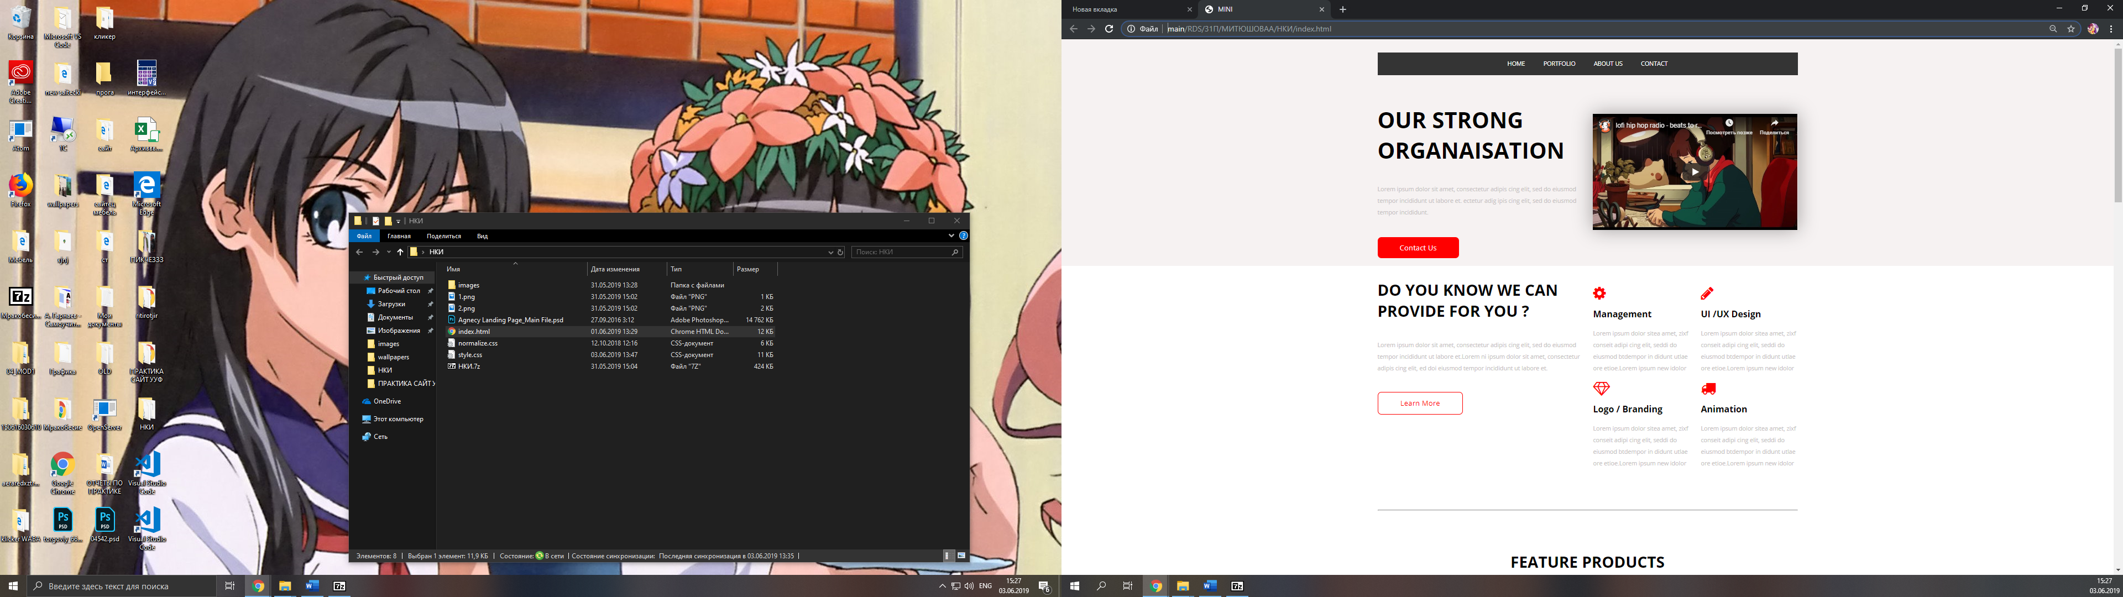

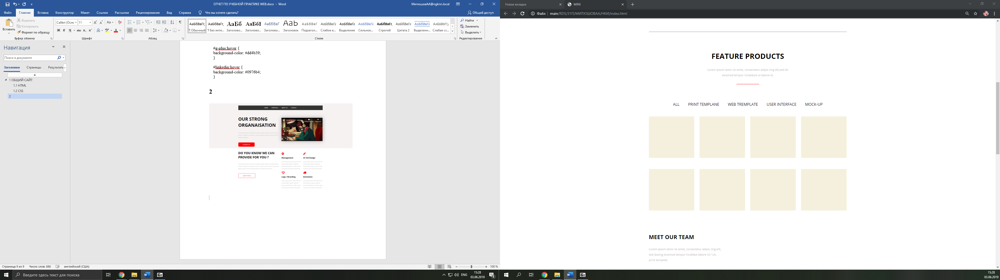

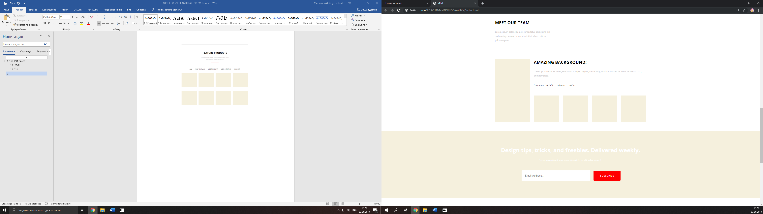

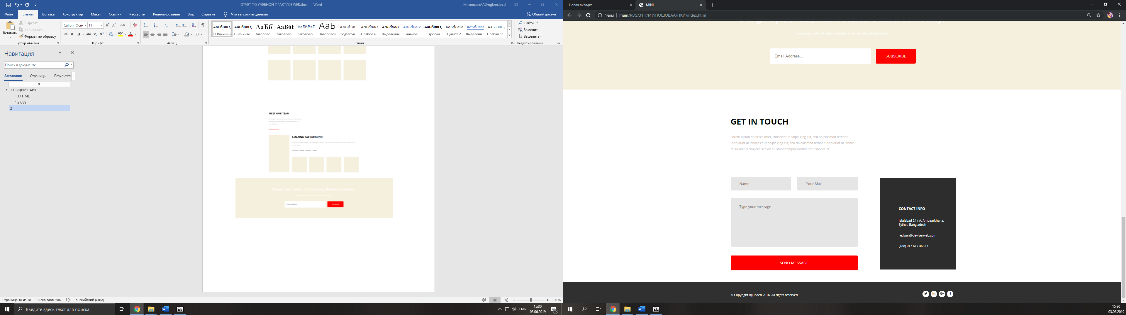

## 2.1 HTML

<body>

<header class="top_menu">

<article style="padding-top: 36px; padding-bottom: 36px; background-color: #f6f2f2">

<div class="container">

<div class="row">

<div class="col-12 menu">

<ul class="main-menu">

<li><a href="index.html">HOME</a></li>

<li><a href="#portfolio">PORTFOLIO</a></li>

<li><a href="#about">ABOUT US</a></li>

<li><a href="#contact">CONTACT</a></li>

</div>

<div class="col-6 strong">

<h1>OUR STRONG ORGANAISATION</h1>

<p>Lorem ipsum dolor sit amet, consectetur adipis cing elit, sed do eiusmod tempor incididunt ut

labore et. ectetur adig ipis cing elit, sed do eiusmod tempor incididunt.</p>

<a href="#">Contact Us</a>

</div>

<div class="col-6 video">

<iframe width="555" height="315" src="https://www.youtube.com/embed/hHW1oY26kxQ" frameborder="0" allow="accelerometer; autoplay; encrypted-media; gyroscope; picture-in-picture" allowfullscreen></iframe>

</div>

</div>

</div>

</article>

</header>

<article style="height: 2670px;; padding-top: 36px; background-color: white"><a id="portfolio"></a>

<div class="container">

<div class="row">

<div class="col-6 strong1">

<h1>do you know we can

provide for you ?</h1>

<p>Lorem ipsum dolor sit amet, consectetur adipis cing elit, sed do eiusmod tempor incididunt ut

labore et.Lorem ni ipsum dolor sit amet, consectetur adipis cing elit, ed doi eiusmod tempor

incididunt ut labore et.</p>

<a href="#">Learn More</a>

</div>

<div class="col-6">

<div class="row">

<div class="col-6 service">

<i class="fa fa-cog" aria-hidden="true"></i>

<h3>Management</h3>

<p>Lorem ipsum dolor sitea amet, zixf conseit adipi cing elit, seddi do eiusmod

btdempor in

didunt utlae ore etioe.Lorem ipsum new idolor</p>

</div>

<div class="col-6 service">

<i class="fa fa-pencil" aria-hidden="true"></i>

<h3>UI /UX Design</h3>

<p>Lorem ipsum dolor sitea amet, zixf conseit adipi cing elit, seddi do eiusmod

btdempor in

didunt utlae ore etioe.Lorem ipsum new idolor</p>

</div>

<div class="col-6 service">

<i class="fa fa-diamond" aria-hidden="true"></i>

<h3>Logo / Branding</h3>

<p>Lorem ipsum dolor sitea amet, zixf conseit adipi cing elit, seddi do eiusmod

btdempor in

didunt utlae ore etioe.Lorem ipsum new idolor</p>

</div>

<div class="col-6 service">

<i class="fa fa-truck" aria-hidden="true"></i>

<h3>Animation</h3>

<p>Lorem ipsum dolor sitea amet, zixf conseit adipi cing elit, seddi do eiusmod

btdempor in

didunt utlae ore etioe.Lorem ipsum new idolor</p>

</div>

</div>

</div>

<div class="col-12 palka">

<hr class="ro" style="height: 3px; background-color: rgb(172, 169, 169);">

</div>

<div class="col-12 product">

<h2>feature products</h2>

<p>Lorem ipsum dolor sit amet, consectetur adipis cing elit,sed do eiusmod tempor incididunt ut

labore et.</p>

<hr color="red">

</div>

<div class="col-12">

<ul class="menu3">

<li><a href="#">ALL</a></li><br>

<li><a href="#">PRINT TEMPLANE</a></li><br>

<li><a href="#">WEB TREMPLATE</a></li><br>

<li><a href="#">USER INTERFACE</a></li><br>

<li><a href="#">MOCK-UP</a></li><br>

</ul>

</div>

<div class="col-3 image_item">

<div class="item">

</div>

</div>

<div class="col-3 image_item">

<div class="item">

</div>

</div>

<div class="col-3 image_item">

<div class="item">

</div>

</div>

<div class="col-3 image_item">

<div class="item">

</div>

</div>

<div class="col-3 image_item">

<div class="item">

</div>

</div>

<div class="col-3 image_item">

<div class="item">

</div>

</div>

<div class="col-3 image_item">

<div class="item">

</div>

</div>

<div class="col-3 image_item">

<div class="item">

</div>

</div>

<div class="col-12 meet">

<h2>Meet our team</h2>

<p>Lorem ipsum dolor sit amet, consectetur adipis cing elit, sed dooing eiusmod tempor incididut

labore Ui / Ux , print template.</p>

<hr color="red">

</div>

<div class="col-3">

<img class="foc1" src="2.png" tabindex="1" />

</div>

<div class="col-9 waugh">

<h2 id="h2-1">amazing background!</h2>

<p>Lorem ipsum dolor sit amet, consectetur adipis cing elit, sed dooing eiusmod tempor incididut

labore Ui / Ux , print template.</p>

<ul class="menu2">

<li><a href="#">Facebook</a></li><br>

<li><a href="#">Dribble</a></li><br>

<li><a href="#">Behance</a></li><br>

<li><a href="#">Twitter</a></li><br>

</ul>

<div class="row focus">

<div class="col-3 thumbs">

<img id="as-1" src="1.png" alt="Light">

<div class="caption">

<span class="title">Заголовок картинки</span>

</div>

</div>

<div class="col-3 thumbs">

<img id="as-2" src="1.png" alt="">

<div class="caption">

<span class="title">Заголовок картинки</span>

</div>

</div>

<div class="col-3 thumbs">

<img id="as-3" src="1.png" alt="">

<div class="caption">

<span class="title">Заголовок картинки</span>

</div>

</div>

<div class="col-3 thumbs">

<img id="as-4" src="1.png" alt="">

<div class="caption">

<span class="title">Заголовок картинки</span>

</div>

</div>

</div>

</div>

</div>

</div>

</article>

<article style="height: 510px; padding-top: 36px; background-color: #f5f0dd;"><a id="about"></a>

<div class="container">

<div class="row">

<div class="col-12 source">

<h2>Design tips, tricks, and freebies. Delivered weekly.</h2>

<p>Lorem ipsum dolor sit amet, consectetur adipis cing elit, sed do eiusmod.</p>

<div class="subb">

<input type="text" placeholder="Email Address..." />

<a href="#">SUBSCRIBE</a>

</div>

</div>

</div>

</div>

</article>

<article style="height: 990px; padding-top: 36px; background-color: white;"><a id="contact"></a>

<div class="container">

<div class="row">

<div class="col-7 touch">

<h2>get in touch</h2>

<p>Lorem ipsum dolor sit amet, consectetur adipis cing elit, sed do eiusmod tempor incididunt ut

labore et.ur adipis cing elit, sed do eiusmod tempor incididunt ut labore et. ur adipis cing

elit, sed do eiusmod tempor incididunt ut labore et.</p>

<hr color="red">

<div class="row">

<div class="col-6 name">

<input type="text" placeholder="Name" />

</div>

<div class="col-6 name">

<input type="text" placeholder="Your Mail" />

</div>

</div>

<textarea placeholder="Type your message"></textarea>

<div class="mas">

<a href="#">SEND MESSAGE</a>

</div>

</div>

<div class="col-1"></div>

<div class="col-4 info">

<h3>Contact info</h3>

<p>Jalalabad 24 / A, Ambaarkhana, Sylhet,

Bangladesh</p>

<p>redwan@deviserweb.com</p>

<p>(+88) 017 617 46373</p>

</div>

</div>

</div>

</article>

<footer style="height: 110px; padding-top: 36px; background-color: #313030;">

<div class="container">

<div class="row">

<div class="col-4 copy">

<p>© Copyright @Junaed 2016, All rights reserved.</p>

</div>

<div class="col-4"></div>

<div class="col-4 social">

<a href="#"> <i class="fa fa-facebook" aria-hidden="true"></i></a>

<a href="#"> <i class="fa fa-google-plus" aria-hidden="true"></i></a>

<a href="#"> <i class="fa fa-linkedin" aria-hidden="true"></i></a>

<a href="#"><i class="fa fa-twitter" aria-hidden="true"></i></a>

</div>

</div>

</div>

</footer>

<script src=""></script>

<script src="jquery-3.3.1.min.js"></script>

<script src="jojo.js"></script>

</body>

</html>

## 2.2 CSS

@import url('https://fonts.googleapis.com/css?family=Open+Sans:300,300i,400,400i,600,600i,700,700i,800,800i&display=swap');

* {

box-sizing: border-box;

margin: 0;

padding: 0;

}

.container {

width: 1170px;

margin: 0 auto;

padding-left: 15px;

padding-right: 15px;

}

.row {

display: flex;

margin-left: -15px;

margin-right: -15px;

flex-wrap: wrap;

}

body{

height: 100vh;

}

.col-1 {

flex: 0 0 8.333%;

padding-left: 15px;

padding-right: 15px;

}

.col-2 {

flex: 0 0 16.666%;

padding-left: 15px;

padding-right: 15px;

}

.col-3 {

flex: 0 0 24.999%;

padding-left: 15px;

padding-right: 15px;

}

.col-4 {

flex: 0 0 33.332%;

padding-left: 15px;

padding-right: 15px;

}

.col-5 {

flex: 0 0 41.665%;

padding-left: 15px;

padding-right: 15px;

}

.col-6 {

flex: 0 0 49.998%;

padding-left: 15px;

padding-right: 15px;

}

.col-7 {

flex: 0 0 58.331%;

padding-left: 15px;

padding-right: 15px;

}

.col-8 {

flex: 0 0 66.664%;

padding-left: 15px;

padding-right: 15px;

}

.col-9 {

flex: 0 0 74.997%;

padding-left: 15px;

padding-right: 15px;

}

.col-10 {

flex: 0 0 83.330%;

padding-left: 15px;

padding-right: 15px;

}

.col-11 {

flex: 0 0 91.663%;

padding-left: 15px;

padding-right: 15px;

}

.col-12 {

flex: 0 0 100%;

padding-left: 15px;

padding-right: 15px;

}

.main-menu{

list-style: none;

padding: 0;

display: flex;

justify-content: center;

align-items: center;

background-color: #343434;

}

.main-menu > li > a{

text-decoration: none;

color: white;

display: block;

padding: 20px 25px;

font-family: 'Open Sans', sans-serif;

}

.main-menu > li:not(.link-img):hover > a{

background-color: red;

}

.strong h1{

padding-top: 80px;

font-size: 60px;

font-family: 'Open Sans', sans-serif;

font-weight: 700;

}

.strong p{

padding-top: 50px;

font-family: 'Open Sans', sans-serif;

font-size: 16px;

color: #c7c3c3;

padding-bottom: 65px;

line-height: 2;

}

.strong a{

text-decoration: none;

color: white;

padding: 15px 60px;

background-color: red;

font-family: 'Open Sans', sans-serif;

font-size: 20px;

border-radius: 10px;

}

.video iframe{

margin-top: 105px;

width: 555.04px;

box-shadow: 0 0 50px rgba(0, 0, 0, 0.336);

}

.strong1 h1{

text-transform: uppercase;

font-family: 'Open Sans', sans-serif;

text-transform: uppercase;

font-size: 42px;

}

.strong1 p{

padding-top: 50px;

font-family: 'Open Sans', sans-serif;

font-size: 16px;

color: #c7c3c3;

padding-bottom: 65px;

line-height: 2;

}

.strong1 a{

text-decoration: none;

color: red;

padding: 15px 60px;

background-color: white;

font-family: 'Open Sans', sans-serif;

font-size: 20px;

border: 2px red solid;

border-radius: 10px;

}

.service i{

padding-top: 20px;

padding-bottom: 20px;

font-size: 40px;

color: red;

}

.service h3{

font-family: 'Open Sans', sans-serif;

font-size: 24px;

padding-bottom: 20px;

}

.service p{

font-family: 'Open Sans', sans-serif;

font-size: 16px;

color: #c7c3c3;

line-height: 2;

}

.palka{

padding-top: 110px;

padding-bottom: 110px;

}

.product h2{

text-transform: uppercase;

font-family: 'Open Sans', sans-serif;

text-transform: uppercase;

font-size: 42px;

text-align: center;

}

.product p{

padding-top: 35px;

font-family: 'Open Sans', sans-serif;

font-size: 16px;

color: #c7c3c3;

line-height: 2;

text-align: center;

padding-bottom: 35px;

width: 480px;

margin: 0 auto;

}

.product hr{

width: 130px;

text-align: center;

height: 2px;

color: red;

margin: 0 auto;

}

.menu3{

margin-top:80PX;

list-style: none;

padding: 0;

display: flex;

justify-content: center;

align-items: center;

}

.menu3 > li > a{

text-decoration: none;

color: black;

display: block;

font-size: 22PX;

padding: 20px 25px;

font-family: 'Open Sans', sans-serif;

}

.menu3 > li:not(.link-img):hover > a{

color: red;

}

.item{

height: 240px;

background-color: #f5f0dd;

}

.image_item{

padding-top: 35px;

padding-bottom: 30px;

}

.meet h2{

margin-top: 100px;

text-transform: uppercase;

font-family: 'Open Sans', sans-serif;

text-transform: uppercase;

font-size: 32px;

text-align: left;

}

.meet p{

margin-top: 35px;

font-family: 'Open Sans', sans-serif;

font-size: 16px;

color: #c7c3c3;

line-height: 2;

width: 430px;

}

.meet hr{

margin-top: 55px;

width: 130px;

text-align: left;

height: 2px;

color: red;

margin-bottom: 70px;

}

.waugh h2{

text-transform: uppercase;

font-family: 'Open Sans', sans-serif;

text-transform: uppercase;

font-size: 32px;

text-align: left;

}

.waugh p{

margin-top: 35px;

font-family: 'Open Sans', sans-serif;

font-size: 16px;

color: #c7c3c3;

line-height: 2;

}

.source h2{

margin-top: 80px;

text-align: center;

color: white;

font-family: 'Open Sans', sans-serif;

font-size: 42px;

}

.source p{

margin-top: 40px;

text-align: center;

color: white;

font-size: 16px;

padding-bottom: 70PX;

}

.focus img{

height: 400px;

max-width: 100%;

margin-bottom: -100px;

z-index: 1000;

}

.foc1{

max-width: 100%;

height: 473px;

background-size: contain;

}

.subb input{

width: 520px;

margin-left: 200px;

display: inline-block;

height: 80px;

border: 0px lightgray solid;

border-radius: 5px;

transition: .5s;

padding-left: 25px;

font-size: 20PX;

}

.subb a{

margin-left: 20px;

align-items: center;

text-decoration: none;

color: white;

padding: 25px 50px;

background-color: red;

font-family: 'Open Sans', sans-serif;

font-size: 20px;

border-radius: 5px;

}

.touch h2{

margin-top: 100px;

text-transform: uppercase;

font-family: 'Open Sans', sans-serif;

text-transform: uppercase;

font-size: 42px;

text-align: left;

}

.touch p{

margin-top: 35px;

font-family: 'Open Sans', sans-serif;

font-size: 16px;

color: #c7c3c3;

line-height: 2;

}

.touch hr{

margin-top: 55px;

width: 130px;

text-align: left;

height: 2px;

color: red;

margin-bottom: 70px;

}

.name input{

width: 310px;

font-family: 'Open Sans', sans-serif;

background-color: #e5e5e5;

height: 70px;

border: 0px #e5e5e5 solid;

border-radius: 5px;

transition: .5s;

padding-left: 45px;

font-size: 18PX;

}

.name{

padding-bottom: 40px;

}

.touch textarea{

width: 100%;

height: 250px;

font-family: 'Open Sans', sans-serif;

background-color: #e5e5e5;

border-radius: 5px;

font-size: 14px;

transition: .5s;

border: none;

resize: none;

font-size: 18PX;

padding-top: 30px;

padding-left: 45px;

}

.mas a{

align-items: center;

text-decoration: none;

color: white;

padding: 25px 253px;

background-color: red;

font-family: 'Open Sans', sans-serif;

font-size: 20px;

border-radius: 5px;

}

.mas{

padding-top: 66px;

}

.info{

float: right;

margin-top: 420px;

background-color: #2d2d2d;

height: 470px;

}

.info h3{

margin-left: 80PX;

margin-top: 145PX;

font-size: 18px;

font-family: 'Open Sans', sans-serif;

color: white;

text-transform: uppercase;

padding-bottom: 20PX;

}

.info P{

font-size: 16px;

padding-top: 17PX;

padding-bottom: 17PX;

color: white;

margin-left: 80PX;

font-family: 'Open Sans', sans-serif;

}

.copy p{

margin-top: 20px;

font-family: 'Open Sans', sans-serif;

color: white;

font-size: 16px;

}

.social a{

margin-top: 10px;

float: right;

margin-left: 10px;

color: #2d2d2d;

}

.social i{

border: 1px solid white;

border-radius: 50%;

background-color: white;

width: 32px;

height: 32px;

padding-top: 6px;

text-align: center;

justify-content: center;

align-items: center;

align-content: center;

}

.focus{

padding-top:30px;

}

.thumbs img {

display: block;

width: 100%; /* ширина картинки */

height: 200px; /* высота картинки */

backface-visibility: hidden;

-webkit-backface-visibility: hidden;

}

.thumbs .caption span {

display: block;

padding: 10px 0;

opacity: 0;

position: relative;

-webkit-transition-property: top, opacity;

transition-property: top, opacity;

-webkit-transition-duration: 0.3s;

transition-duration: 0.3s;

-webkit-transition-delay: 0s;

transition-delay: 0s;

margin-top: 62px;

background-color: #7a786e;

font-family: 'Open Sans', sans-serif;

color: white;

text-align: center;

}

.thumbs .caption .title {

line-height: 1;

font-weight: normal;

font-size: 18px;

}

.thumbs .caption {

line-height: 1.2;

margin-top: 5px;

font-size: 12px;

}

.thumbs:focus:before,

.thumbs:focus span, .thumbs:hover:before,

.thumbs:hover span {

opacity: 1;

}

.thumbs:focus:before, .thumbs:hover:before {

top: 50%;

}

.thumbs:focus span, .thumbs:hover span {

top: 0;

}

.thumbs:focus .title, .thumbs:hover .title {

-webkit-transition-delay: 0.15s;

transition-delay: 0.15s;

}

.menu2{

margin-top:40PX;

list-style: none;

padding: 0;

display: flex;

justify-content: left;

padding-bottom: 38px;

}

.menu2 > li > a{

text-decoration: none;

color: #585858;

display: block;

font-size: 18PX;

font-family: 'Open Sans', sans-serif;

padding-right: 20px;

font-style: italic;

}

.menu2 > li:not(.link-img):hover > a{

color: red;

}

.eee{

background-color: #2d2d2d;

position: absolute;

margin-right: 200px;

width: 100%;

float: right;

}

# 3